Aipotu I: Genetics

Objectives:
- To reinforce your understanding of Genetics, Biochemistry, and Molecular Biology
- To show the connections between these three disciplines
- To show how these three approaches can be combined to give a complete picture of a biological phenomenon
- To figure out a complete explanation of a biological phenomenon
- To experience how scientists develop and test hypotheses

Introduction:

Aipotu (pronounced “ā pō too“ – the word is “utopia” spelled backwards) is a simulated world where users can explore a biological phenomenon in terms of genetics, biochemistry, molecular biology, and evolution.

The Biological Phenomenon Under Study
In this lab, you will explore the biological mechanisms behind the expression of flower color in a hypothetical plant. These flowers can be white, red, orange, yellow, green, blue, purple, or black.

Scenario:
You are the chief biologist for a breeder of fine flowers. Your company sells seeds that customers plant in their gardens. Since most of your customers expect that the flowers will grow each year from seeds produced the previous year, you try to produce true-breeding plants whenever you can.

You’ve found a new species of flower with an attractive shape. You’ve collected four plants from the wild: two green, one red, and one white. Your customers would really like to have purple flowers from this plant. You set out to create a true-breeding purple flower.

Hypothesis Testing
In the three Aipotu labs, you will use a process much like that used by practicing scientists as they conduct research. Although this process almost never follows a formula, it often proceeds as follows:
- Observe Patterns. Observe the natural world and look for patterns, exceptional events, etc. For example, you might observe that red flowers sometimes have white offspring.
- Develop hypotheses. From the observations, you define testable hypotheses – statements or questions that can be addressed experimentally. Continuing the example, you might reasonably hypothesize that red is dominant to white.
- Test hypotheses. You then set up experiments or observations that will collect data that bear on your hypothesis. In the example, you might cross pure-breeding white with pure-breeding red. If your hypothesis is correct, all the offspring will be red. If you get another result, your hypothesis is incorrect.
- Revise hypotheses as necessary. If your results do not match your prediction, you need to revise your hypothesis and go to Step (3) again until they do match.
You have already been doing this informally in the VGL labs. You should note that this process never really ends – typically there is more to investigate once you’ve reached a satisfactory conclusion.

The “answer” vs the “point”
Although there is an answer – the complete model of color formation in these plants – and you can find it with the tools in Aipotu, having the answer is not as important as finding the answer. We could just tell you the answer, but that would leave out the major learning goals of this lab:
- Experiencing how scientific hypothesis testing works.
- Experiencing how you can use the tools of modern biology to completely understand a phenomenon.
So, while we will work together to find ‘the answer’, the real point of the lab is the journey.

Unifying Three Parts of Modern Biology
The three major parts of this course are:
- Genetics = explaining biological phenomena in terms of genes. How is flower color inherited?
- Biochemistry = explaining biological phenomena in terms of proteins and other molecules. How does protein sequence determine protein structure and color?
- Molecular Biology = explaining the connection between genes (DNA) and protein. How does the DNA sequence of the color gene lead to a particular color?

The connections between these three fields of biology are shown below in a diagram credited to David Botstein (each of the arrows corresponds to “can be explained in terms of”, the words in this font are the different disciplines of biology):

genes

individual
life functions Molecular
Biochemistry
Genetics
of living things Biology

proteins

Understanding any biological phenomenon requires information from all three of these disciplines. Throughout this course, you will re-visit this lab to create an increasingly complete picture of the phenomenon under study. Each time, you will add to the model of color production in these flowers.

Getting Aipotu
Because Aipotu is under constant development, you should always use the latest version. As a result, it is not installed on the computers. You should download it from http://intro.bio.umb.edu/aipotu/ or the link on the On-Line Lab Manual for this lab. It will then be installed on the desktop.

Tools Available in Aipotu
For each of the three disciplines, there is a different tool in Aipotu that will allow you to explore the same set of creatures using a different set of techniques:

- Genetics. The flowers in this simulation are diploids. As with most flowers, they are all hermaphrodites (both male and female). With this tool, you can perform the following experiments:
  - Cross any two organisms. A new window will appear with the offspring of this cross.
  - Self-cross any organism. In this case, the single selected organism is both mother and father to the resulting offspring.
  - Mutate any organism. A new window will appear with a set of flowers that are mutant versions of the selected organism.

- Biochemistry. The color in these flowers results from the form(s) of pigment proteins present in an individual plant. With this tool, you can perform the following experiments:
  - Examine the pigment proteins present in a plant. The tool shows you the amino acid sequence and two-dimensional structure of the pigment proteins present in a given plant.
  - Design your own proteins. You can edit an existing protein sequence or type in an entirely new sequence. The program will then predict the two-dimensional structure of the resulting protein as well as its color. It will also predict the color resulting from the combination of any two proteins.

- Molecular Biology. The pigment proteins in these plants are produced by pigment protein genes. With this tool, you can perform the following experiments:
  - Examine the pigment protein genes present in a plant. The tool shows the DNA, pre-mRNA, mature mRNA, and protein sequences present in a given plant. You can explore the introns, exons, etc. of these genes.
  - Design your own genes. You can edit an existing DNA sequence or type in an entirely new sequence. The program will then predict the mRNA, protein sequence, two-dimensional structure of the resulting protein as well as its color. It will also predict the color resulting from the combination of any two proteins.
  - Design your own plants. You can save edited DNA sequences as new organisms for further study.

When you start Aipotu, the program will load the four starting flower types into the Greenhouse, you will then see a screen like this:
The Greenhouse contains the starting set of organisms.
These Buttons select the tool you will be using.
These are the Menus; they apply to all the tools.

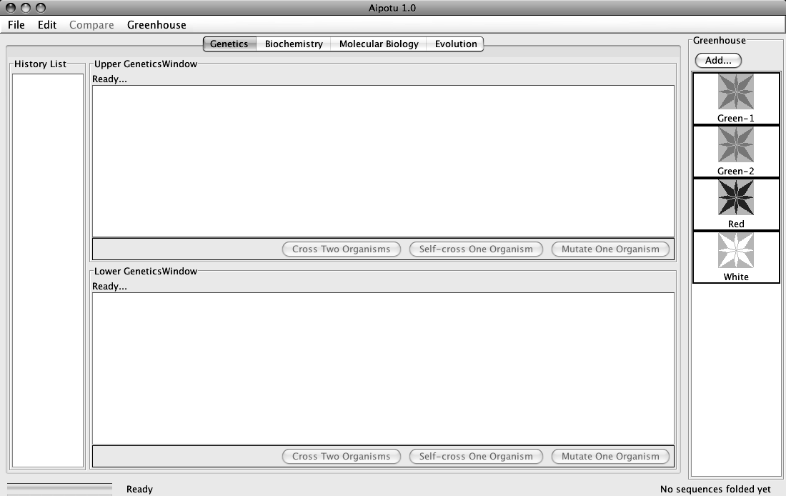
The History List stores the results of each of your experiments. These results can be sent to the upper or lower panes (see later).
Upper Work Panel.
Results of crosses, etc. will appear here.
Lower Work Panel.
Results of crosses, etc. will appear here.

Each organism is shown as a flower:
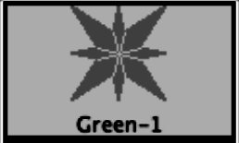
The color of the picture shows the color of the flower. These flowers can be white, red, orange, yellow, green, blue, purple, or black. When any organism is selected, the black border turns green to show that it has been selected.

The next sections of this manual will show you the various tools and the tasks that you will need to carry out.

Part I: Genetics - Crosses

Tasks:
- Determine how color is inherited in these flowers. NOTE: the color is controlled by one gene only.
  - Determine the colors of the alleles present in the original set of organisms.
  - Which alleles are dominant?
  - Which alleles are recessive?
  - How do the alleles combine to produce the overall color of the plant?
- Construct a purple organism to demonstrate your understanding of this process.

Using the tool:
You can switch to this tool by clicking the “Genetics” tab near the top of the window.

There are three kinds of experiments you can perform with this tool. The following sections use examples to show you how to do each; you will need to devise your own experiments to carry out the tasks above.

I) Cross Two Organisms. Suppose that you wanted to cross Red and White:

1) Click on Green-1 and then on White in the Greenhouse. The rectangular borders of
both should turn green to show that they have been selected. The “Cross Two
Organisms” buttons in the Upper and Lower Work Panels should be activated.

2) Click the “Cross Two Organisms” button in the Upper Work Panel. You should see
something like this:
These are the offspring of the cross. You can select any of these for crossing, etc.

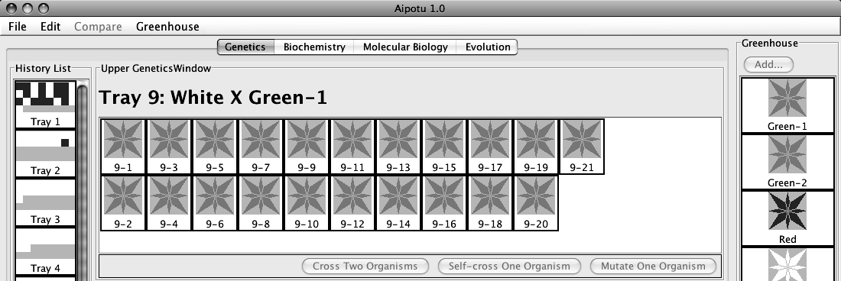

This represents the Tray of plants containing the offspring you just produced. The colored squares represent the different colors of the offspring produced.

If you double-click on the Tray in the History List, you get a pop-up menu with a list of useful options:

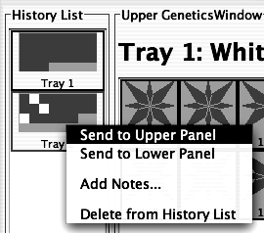

- Send to Upper Panel: Sends this Tray to the Upper Panel so you can cross those organisms.
- Send to Lower Panel: Sends this Tray to the Lower Panel so you can cross those organisms.
- Add Notes...: Allows you to add notes to the Tray in the History List. These notes will appear if you leave the cursor over the Tray for a few seconds.
- Delete from History List: deletes the Tray from the History List; this is cannot be undone.
II) Self-cross a single Organism. Suppose that you wanted to self-cross one of the offspring in Tray 1:

1) Select any one organism from Tray 1 in the Upper Work Panel. You can de-select an
organism by clicking on it. When you have only one organism selected, the
“Cross Two Organisms” buttons will be grayed out and the “Self-Cross One Organism” and “Mutate One Organism” buttons will be activated.

2) Click the “Self-Cross One Organism” button in the Lower Work Panel. You should
see something like this (since offspring are generated by random choice of
parental alleles, you will likely see slightly different numbers of red and white
offspring):

You should see something like this:
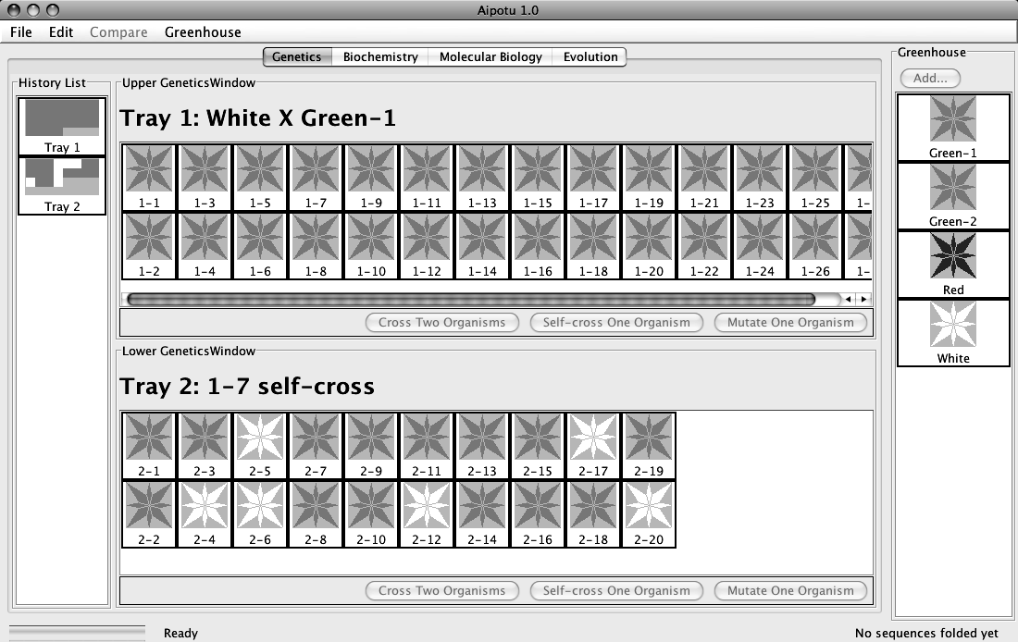
The offspring of this self-cross are in the Lower Work Panel. Note the addition of Tray 2 to the History List.

At this point, there are several other things you can do:

A) If you find an interesting organism, you can save it to the Greenhouse:

1) Click the “Add…” button at the top of the Greenhouse.

2) You will be prompted to give the organism a name. Give it a descriptive name and
click “OK”. You will see your new organism appear in the Greenhouse. You
can now access it using the other tools in this program.

3) At this point, the organism is saved in the program, but not on the disk. To save the
contents of the Greenhouse to disk, click on the Greenhouse Menu and select “Save Greenhouse”.

B) You can cross or mutate any of the organisms visible in the Greenhouse, Upper Work
Panel, or Lower Work Panel.

C) You can bring any Tray from the History List to a Work Panel by double-clicking the Tray and selecting the appropriate item in the pop-up menu.

D) You can add notes to any Tray in the History List by double-clicking the Tray and choosing the “Add Notes...” item from the resulting pop-up menu. These notes will appear if you leave the cursor over the Tray for a few seconds.

IMPORTANT NOTE:
This software is under development. Please treat it gently and be patient. Please report any bugs to your TA. You should save your Greenhouse regularly, especially if you save a large number of organisms.

Specific Tasks to do with this tool:
- How many different alleles are there? Which colors do they produce? It will be useful to use multiple-allele notation like this: C^{R} = red; C^{G} = green, etc.
- Which are dominant and which are recessive?
- How do the colors combine to produce an overall color? For this, it may help to make a genotype-phenotype table and then try to abstract rules from that. You should be sure that you have tried all the possible combinations of the alleles you found in part (a).
- Using the symbols you have developed, give the genotypes of the four starting organisms.
- Using this knowledge, construct a purple flower.
- Can you construct a pure-breeding purple flower with the starting set of organisms?
- Post your findings to your section’s Lab Data Blog.

How to go about accomplishing these tasks
Follow the procedure from page (1) – look for patterns, make hypotheses, test hypotheses, revise hypotheses. Today, we will not write them out formally, but you should be thinking in these terms for the Aipotu II and III labs.
Put your data in the tables below:

(a) and (b) allele color

(c) Genotype Phenotype

What rules can you find to explain the data above?

(d) Using the allele symbols above, what are the genotypes of the starting strains?

Green-1:

Green-2:

Red:

White:

(e) Have your TA check off that you have constructed a purple flower. For full credit, you must be able to explain to your TA why the flower is purple.

(f) Can you construct a pure-breeding purple flower using only the four starting strains? Why or why not?

(g) Have one group post your results to your section’s Lab Data Blog as described in the Mitosis Animation Lab.

Part II: Genetics - Mutation

Another very important way scientists study a process is to alter it by mutation and see what happens. You will make a mutant organism now and then explore it in detail in the Aipotu II and Aipotu III labs.

Tasks:
- Make a mutant version of one of the starting alleles that has a different color.
- Note the change to it’s color, protein sequence, and DNA sequence.
- Save it for later analysis.

Using the Tool
Mutate any one organism. This simulates treating the cells of one organism with a strong dose of a mutagen and then growing each of those mutant cells into a separate plant. The flowers of the resulting mutant plants are displayed in a new Tray. This process can take a few minutes. Suppose that you wanted to mutate one of the white organisms in Tray 2:

1) Select a white organism from Tray 2. When you have only one organism selected, the
“Cross Two Organisms” buttons will be grayed out and the “Self-Cross One Organism” and “Mutate One Organism” buttons will be activated.

2) Click the “Mutate One Organism” button in the Upper Work Panel. A pop-up will
appear telling you that the program is busy making mutants. You can cancel this
process if you like.

You will then see a new Tray with the mutants and a new entry in the History List.

Procedure

(1) Make a pure-breeding strain of the color of your choice. Note the color here .

(2) Select one of the pure-breeding organisms and click the Mutate One Organism button.
Wait while it makes the mutants.

(3) With luck, you will see an organism of a different color. If not, try mutating the pure-
breeding strain again until you see another color. Do not mutate an organism that was
already mutated.

(4) Save your mutant organism to the Greenhouse with a descriptive name (like “Green from
Red”).

(5) From the Greenhouse menu, choose Save Greenhouse.

(6) Find out how the mutation has changed the Protein Sequence.
- Click on the Biochemistry tab at the top of Aipotu.
- Double-click on the organism you just saved in the Greenhouse.
- Aipotu then displays the shapes of the proteins produced by the two alleles that this organism is carrying. One of these will be unchanged – it will have the color that you started with; the other will be mutated, resulting in an altered color.
- From the Compare menu, choose Upper vs Lower. A window will pop up showing the two amino acid sequences with differences highlighted in red. Make a note of the difference in the space below.

(7) Find out how the mutation has changed the DNA Sequence.
- Click on the Biochemistry tab at the top of Aipotu.
- Double-click on the organism you just saved in the Greenhouse.
- Aipotu then displays the genes that encode the two alleles that this organism is carrying. One of these will be unchanged – it will have the color that you started with; the other will be mutated, resulting in an altered color.
- From the Compare menu, choose Upper vs Lower. A window will pop up showing the two DNA sequences with differences highlighted in red. Make a note of the difference in the space below.

(8) Make a blog post with your organism in your section’s Lab Data Blog. Make the subject be something like “Blue from red: Brian, Julie, and Will”. Your post should include:
- The starting color and the final color.
- The change(s) in the protein sequence.
- The change(s) in the DNA sequence.
- Be sure to attach the organism file to the blog post. You can find it by going to the Desktop, then into the Aipotu folder, and finally into the Greenhouse folder. Select only your new organism. You will explore this organism in more detail in following labs.

You will continue this project in the second part of the lab in a few weeks.

